**Latvia has established following sea areas for different classes of passenger ships under DIRECTIVE 2009/45/EC Article 4 (2)**

|  |  |
| --- | --- |
| Class “A” | means a sea area outside of areas B, C and D. |
| Class “B” | means a sea area, whose geographical coordinates are at no point more than 20 miles from the line of coast, corresponding to the medium tide height, but which is outside of areas C and D. |
| Class “C” | means a sea area, whose geographical coordinates are at any point no more than 5 miles from the line of coast, corresponding to the medium tide height, but outside of sea area D if any. Additionally the probability of the significant wave height exceeding 2,5 metres in this area is smaller than 10 % for a period of one year for all-year-round operation, or for a specific period for seasonal operation, such as summer period operation. |
| Class “D” | means a sea area, whose geographical coordinates are at any point no more than 3 miles from the line of coast, corresponding to the medium tide height. Additionally the probability of the significant wave height exceeding 1,5 metres in this area is smaller than 10 % for a period of one year for all-year-round operation, or for a specific period for seasonal operation, such as summer period operation |

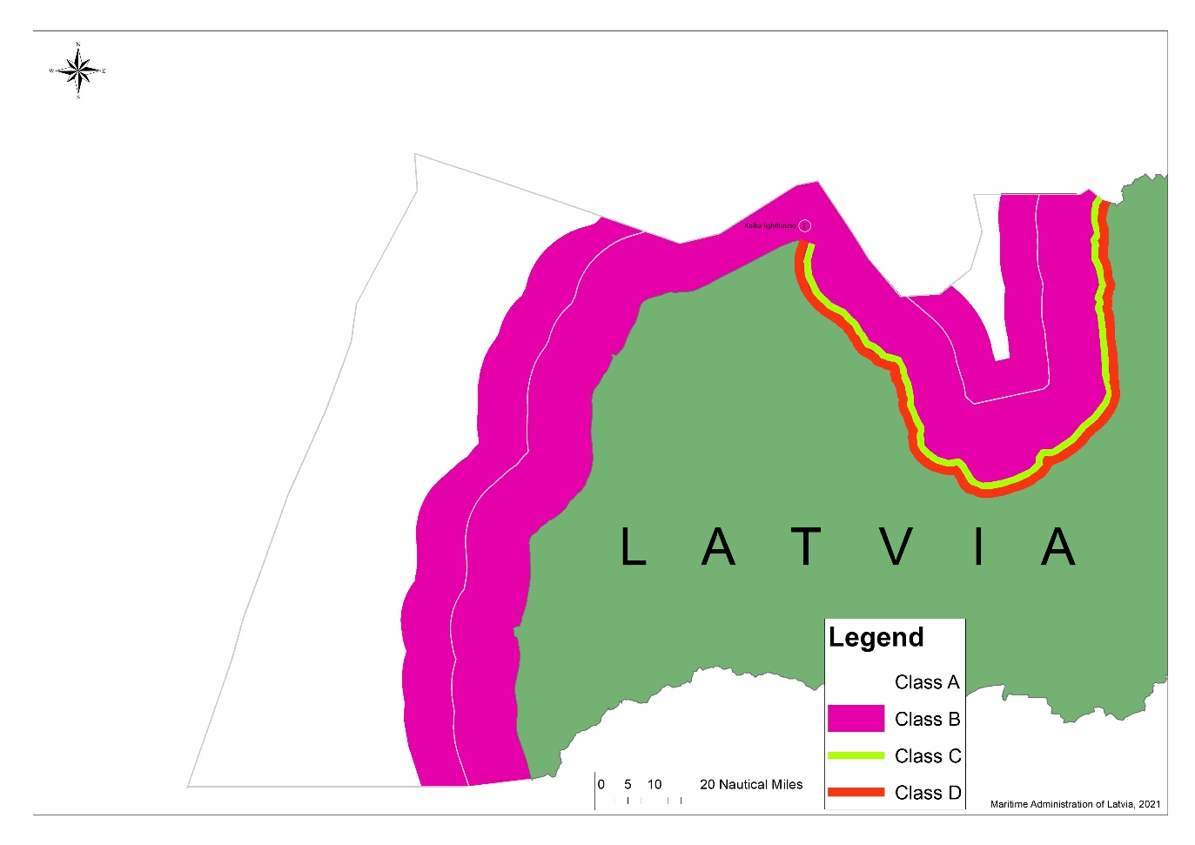

**The delimited zones (Sea areas) are determined using Latvia’s coats line with following coordinates (from W to E):**

|  |  |  |  |  |  |
| --- | --- | --- | --- | --- | --- |
| 1 | 56`04'12.35380N | 21`03'51.82999E | 27 | 57`45'33.22440N | 22`36'17.25718E |
| 2 | 56`09'54.59068N | 21`00'56.74158E | 28 | 57`39'19.90411N | 22`34'48.30737E |
| 3 | 56`15'25.20338N | 20`58'54.30659E | 29 | 57`33'09.09878N | 22`41'27.34631E |
| 4 | 56`19'52.86068N | 20`58'32.52716E | 30 | 57`29'31.73002N | 22`50'47.40281E |
| 5 | 56`24'54.11062N | 20`59'22.55402E | 31 | 57`25'24.07926N | 22`55'40.79514E |
| 6 | 56`27'47.85811N | 20`59'59.29256E | 32 | 57`22'51.26098N | 23`01'46.40840E |
| 7 | 56`30'39.62113N | 20`59'17.84742E | 33 | 57`22'00.72350N | 23`07'17.94619E |
| 8 | 56`31'35.56830N | 20`58'05.65414E | 34 | 57`16'11.68550N | 23`10'21.18414E |
| 9 | 56`33'03.26023N | 20`57'53.57930E | 35 | 57`09'48.03318N | 23`13'53.15733E |
| 10 | 56`33'27.02124N | 20`59'56.42909E | 36 | 57`04'45.14001N | 23`16'32.04145E |
| 11 | 56`37'56.44308N | 21`02'14.44686E | 37 | 57`02'09.34918N | 23`28'59.93487E |
| 12 | 56`43'23.69600N | 21`03'32.34683E | 38 | 56`58'23.17609N | 23`35'38.90732E |
| 13 | 56`49'28.42975N | 21`03'09.06282E | 39 | 56`58'54.85904N | 23`49'28.42587E |
| 14 | 56`50'45.46208N | 21`04'20.46511E | 40 | 57`03'36.65178N | 24`01'14.75563E |
| 15 | 56`53'31.05211N | 21`09'58.76586E | 41 | 57`06'25.19125N | 24`10'25.33024E |
| 16 | 56`54'39.43947N | 21`13'41.45657E | 42 | 57`09'46.55793N | 24`16'16.03562E |
| 17 | 56`57'16.18131N | 21`17'25.99764E | 43 | 57`14'54.99999N | 24`24'02.77246E |
| 18 | 57`03'17.83836N | 21`24'41.33696E | 44 | 57`19'37.50967N | 24`24'13.82417E |
| 19 | 57`17'19.73022N | 21`25'06.05068E | 45 | 57`27'47.18170N | 24`23'17.22915E |
| 20 | 57`24'12.34364N | 21`31'33.05280E | 46 | 57`32'35.97021N | 24`21'48.20809E |
| 21 | 57`30'15.56326N | 21`39'33.85717E | 47 | 57`36'25.22160N | 24`22'45.66809E |
| 22 | 57`34'05.44396N | 21`42'10.16644E | 48 | 57`41'55.97919N | 24`20'40.84252E |
| 23 | 57`35'57.01264N | 21`51'26.90518E | 49 | 57`46'34.60594N | 24`20'49.16683E |
| 24 | 57`36'31.80909N | 22`01'12.37480E | 50 | 57`49'28.99819N | 24`19'57.78720E |
| 25 | 57`40'15.55179N | 22`14'50.09147E | 51 | 57`52'34.90507N | 24`21'11.10865E |
| 26 | 57`44'13.03090N | 22`28'53.15599E |  |  |  |

