**Information on sea areas and their applicable significant wave height values**

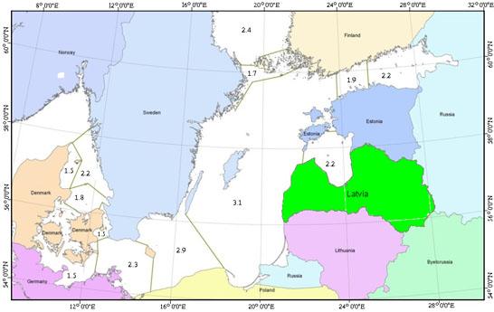

A significant wave height (hs) (the average height of the highest third of the wave heights observed over a specified period of time) is used to determine the height of the water level on the car deck by applying the requirements set out in Annex 1 to Cabinet Regulation No 927 (2010) Regulations Regarding Specific Stability Requirements for Ro-ro Passenger Ships.

A significant wave height value shall be set for the sea area concerned such that the probability of exceeding it during the year is no greater than 10%.

**Significant wave heights of 3.1 m in the middle of the Baltic Sea and 2.2 m in the Gulf of Riga.**